**Payment Gateway**:

* Is a source that authorize and process payments in online.
* A gateway serves as a portal to facilitate transaction flow between customers and merchants.
* It uses security protocols and encryption to pass the transaction data safely. The data is transformed from website to payment process [I e Bank] and back.

**Transactions Types a payment gateways executes:**

1. **Authorization**: used to check if a customer has enough funds to pay, but not actual money transfer. Authorization transaction is used for orders that take time to ship/manufacture.
2. **Capture**: actual processing of previously authorized payment resulting in funds being sent tO the merchant’s account.
3. Refund: result of cancellation order, merchant will apply a refund payment processing to return the money.
4. Void: similar to refund but ca be done, if funds were yet captured.

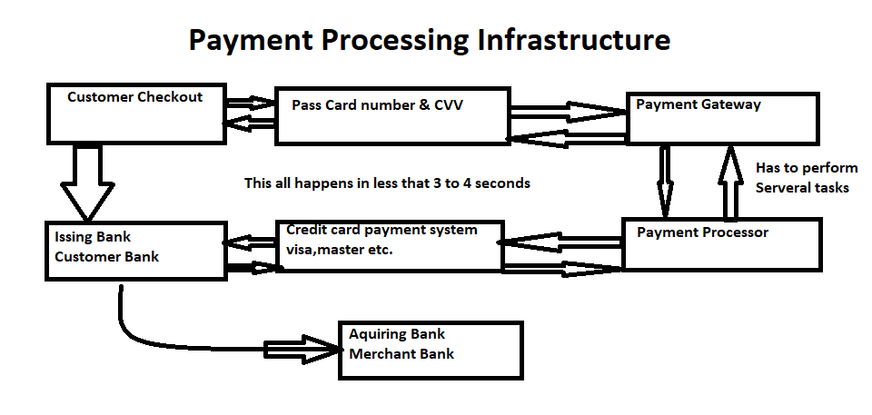

**Actual flow**:

* Customer - presses purchase and fills the required fields to pass the transaction data, then data is encrypted and sent to merchant’s Web Server (SSL connection).
* Merchant and Payment Gateway- after transaction data is received, a merchant passes it to the payment gateway via another encrypted SSL channel.
* Payment Process- then info goes to the payment processors. There are several companies that provides payment processing services as Third party players. Payment processors are connected to both with merchant’s account and a payment gateway, transferring data back and forth. At that stage the payment processor is passing transaction data to a card network (visa, master etc.).
* Visa/Master etc.- The role of the Card network is to verify the transaction data and pass it to the issuer bank (i e Bank issued the credit/debit card).
* Issuer Bank- accepts or declines the authorization request. In response it will send back code to the payment processor, which contains the transaction status or error details.
* Payment gateway- transaction status is returned to the payment gateway then it is passed to the website.
* Customer and issuing bank – customer receive transaction status code via payment system interface.
* Issuing Bank: will transfers to the merchants account. The transaction is performed by issuing bank and merchant bank.

**To Integrate a Payment System into the Website**:

Four main methods to integrate a payment gateway

1. **Hosted Payment Gateway.**
2. **Direct Post Method.**
3. **Non-Hosted (Integrated) Method.**
4. **Considering obtaining PCI DSS compliance Payment card/ creating own application.**

**1.Hosted Payment Gateway:**

* Acts as a Third party, it requires customer to leave the website to complete a purchase.
* Process-a piece of JavaScript code we will receive that places a button on the website, by clicking a button will activate a Paypal’s REST API and checkout flow to process.
* Pros- Client card data is stored by vendor, so hosted gateway require no PCI compliance and offer easy integration because a guide’s are generally open on vender website.

**2.Direct Post Method:**

* Allows customer to stay without leaving the website.
* Transaction data will be posted to payment gateway after customer click purchase, the data is instantly gets to the gateway and process without being stored on website.
* Integration – Vender will set up the API connection between shopping card and its payment gateway to post card details.

**3. Non-Hosted (Integrated) Method**:

* Allows customer to shop without leaving the website.
* Merchant have to PCI compliance because they will be storing client’s card details on their server.
* Integration- are integrated via API to server, it requires an engineering team to perform integration.

**4.Considering obtaining PCI compliance**:

* Need to create own API for card payment processing.

Popular Payment Gateways:

Amazon payments, WePay, Paypal payment, Worldpay. etc.